**GOOD SHEPHERD COLLECTION CLIP ART**

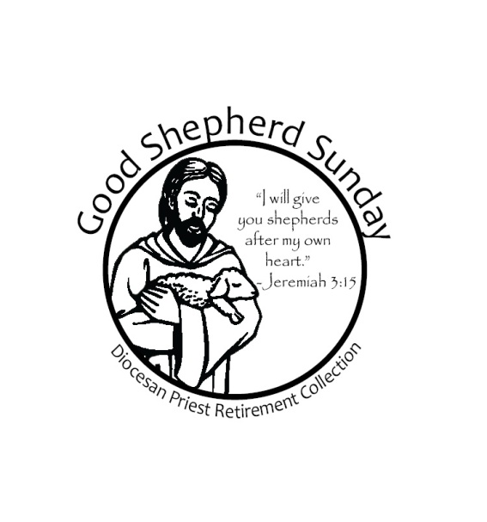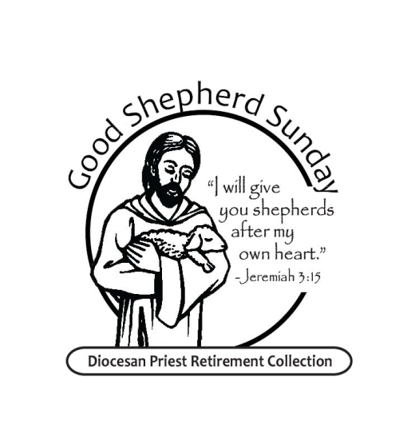

**GOOD SHEPHERD SUNDAY**

**DIOCESAN PRIEST RETIREMENT COLLECTION**

**May 10 & 11, 2025**

**GOOD SHEPHERD**

**COLLECTION**

**BENEFITS**

**ERIE DIOCESAN**

**RETIRED PRIESTS**

**Provides for those retired priests**

**the same love and generosity**

**they provided for us**

**for generations**

***MAY 10 & 11, 2025***

**GOOD SHEPHERD**

**COLLECTION**

**FOR**

**RETIRED**

**DIOCESAN PRIESTS**

**MAY 10 & 11**

**2025**