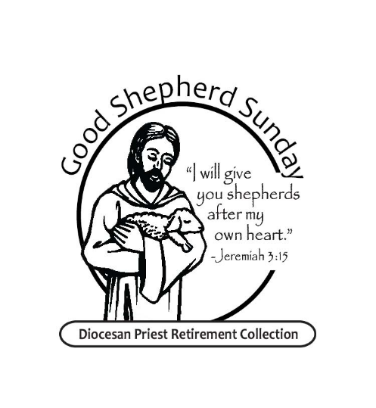GOOD SHEPHERD SUNDAY

DIOCESAN PRIEST RETIREMENT COLLECTION

WORLD DAY OF PRAYER FOR VOCATIONS

GENERAL INTERCESSIONS

May 10 & 11, 2025

Priest: As the Good Shepherd tends his Father’s flock, we trust in His love and care for each of us, and now we bring the needs of our brothers and sisters as we pray:

Reader: Lord, hear our prayer.

For our Holy Father, Pope Francis, for Bishop Persico and all priests that they may grow in the image of Christ the Good Shepherd, and help those they serve grow in their faith, let us pray to the Lord:

* That the leaders of nations defend the right to life of each person, especially the poorest and most vulnerable, let us pray to the Lord:
* For those who are discerning their Christian vocation, and for all seminarians that their minds and hearts will be open to saying “yes” to priestly service, let us pray to the Lord:
* For our retired priests, that the Lord give them good health in body, mind and spirit, and continue to make their lives and their ministry a source of grace for others, let us pray to the Lord:
* For Monsignor/ Father_________________ who serves our parish, that the Holy Spirit will guide and support (his/their) ministry, let us pray to the Lord:
* For those priests who have died this past year, especially: Father William Kuba, Father Robert Humenay, Msgr Tom McSweeney, Father John Fisher and their families and parishioners who grieve their loss, that they may be comforted, let us pray to the Lord:
* For the intentions we hold in our hearts (pause…...) Hear our prayers and strengthen us with your Spirit, let us pray to the Lord:

Priest: Gracious God, we thank you for Jesus, our Good Shepherd. Listen to our prayer as we lift our hearts in the hope of receiving your blessings. Be with us now and forever. Amen.