**Suggested text to accompany Facebook Posts for CSA**

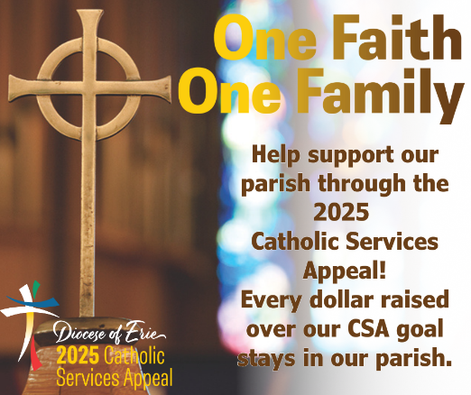

The Catholic Services Appeal is underway! Its success is essential to helping the Diocese of Erie fulfill its mission. Your participation ensures the success of the CSA and is important to the health of our parish. Please join other Catholics from across the 13 counties of our diocese in supporting this important appeal.

*(If you have a parish project you could add a sentence about it. For example: Did you know that every dollar raised over the CSA goal will stay in our parish to support our xyz project?)*

The 2025 Catholic Services Appeal is underway! The CSA funds programs and ministries that are beyond the resources of any one parish. Every diocesan office and ministry supported by the CSA is available to assist in every area of the diocese. The CSA reminds us that we are all part of the same Catholic family and that the work of the diocese is the work of the Church. By joining together, we can accomplish more than any one parish can accomplish on its own.

Remember, no gift is too small, and every dollar raised over our CSA goal stays in our parish.

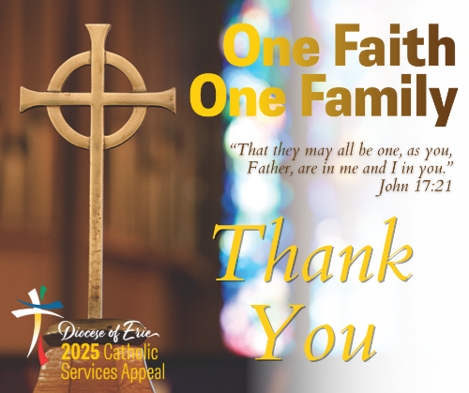

A sincere thank you to all who made a pledge and/or gift to the Catholic Services Appeal. You have joined together with Catholics throughout the Diocese of Erie to share your blessings to help advance the mission of the Church.

If you have not yet made a commitment, it is not too late. Just drop your pledge card or envelope marked ‘CSA’ in the collection basket or turn it in at the parish office.

One Faith, One Family is an invitation for all of us in the Diocese of Erie to deepen our commitment to our shared faith and common mission as one family in Christ. We manifest this unity

as we support essential daily ministries and programs of the Church through the Catholic Services Appeal.

By joining together, we can accomplish more than any one parish can accomplish on its own.

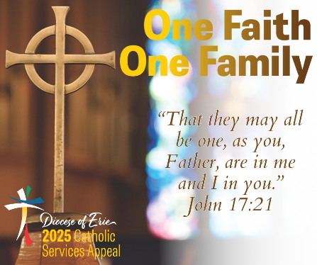

Thank you to everyone who has made a pledge and/or gift to the 2025 Catholic Services Appeal. If you have not yet made a commitment, it is not too late. Just drop your pledge card or envelope marked ‘CSA’ in the collection basket or turn it in at the parish office.

Click the link to read more about how the CSA provides essential funding to many diocesan offices, including Faith Formation. <https://www.eriercd.org/news/United-in-Faith-Transforming-Lives-Through-Prayer-Discipleship-and-Service-with-the-CSA.html>

Thank you to everyone who has made a pledge and/or gift to the 2025 Catholic Services Appeal. If you have not yet made a commitment, it is not too late. Just drop your pledge card or envelope marked ‘CSA’ in the collection basket or turn it in at the parish office.

Click the link to read more about how the CSA provides essential funding to many diocesan offices, including Communications. <https://www.eriercd.org/news/United-in-Faith-Transforming-Lives-Through-Prayer-Discipleship-and-Service-with-the-CSA.html>

Thank you to everyone who has made a pledge and/or gift to the 2025 Catholic Services Appeal. If you have not yet made a commitment, it is not too late. Just drop your pledge card or envelope marked ‘CSA’ in the collection basket or turn it in at the parish office.

Click the link to read more about how the CSA provides essential funding to many diocesan offices, including Catholic Charities. <https://www.eriercd.org/news/United-in-Faith-Transforming-Lives-Through-Prayer-Discipleship-and-Service-with-the-CSA.html>